**RHEL 8 install Python 3 or Python 2 using yum**

last updated March 5, 2019 **in Categories**[**Package Management**](https://www.cyberciti.biz/faq/category/package-management/)**,**[**Python**](https://www.cyberciti.biz/faq/category/python/)**,**[**RedHat and Friends**](https://www.cyberciti.biz/faq/category/redhat-and-friends/)

[https://www.cyberciti.biz/media/new/category/old/rhlogo.gif](https://www.cyberciti.biz/faq/category/redhat-and-friends/)

Ineed to install Python 3 for Ansible IT automation tool on RHEL 8. How do I install Python 3 on RHEL 8? Is it possible to install Python 2 for legacy apps on RHEL 8?  
  
Red Hat Enterprise Linux (RHEL 8) does not install Python 3 or 2 by default as Red Hat didn’t want to set a default. However, system administrators can install Python 3 or 2 as per needs using various methods. This page shows **how to install Python 3 or Python 2.7 on RHEL 8 using**[**yum command**](https://www.cyberciti.biz/faq/rhel-centos-fedora-linux-yum-command-howto/).

**Adblock detected 😱**

My website is made possible by displaying online advertisements to my visitors. I get it! Ads are annoying but they help keep this website running. It is hard to keep the site running and producing new content when so many people block ads. Please consider donating money to the nixCraft via [**PayPal**](https://www.paypal.com/cgi-bin/webscr?cmd=_s-xclick&hosted_button_id=LJF8UGD7QKF3U)/[**Bitcoin**](https://www.cyberciti.biz/tips/donate#BTC), or become a [**supporter using Patreon**](https://www.patreon.com/nixcraft).

**How to Install Python 3 / Python 2.7 on RHEL 8**

The procedure for installing Python 3 on RHEL 8 is as follows:

1. Open the Terminal application or window.
2. Search for python package in RHEL 8, run: **sudo yum search python3**
3. To install python 3 on RHEL 8, run: **sudo yum install python3**
4. To install python 2 on RHEL 8, run: **sudo yum install python2**
5. Upgrade python 3 in RHEL 8, run: **sudo yum upgrade python3**
6. Upgrade python 2 in RHEL 8, run: **sudo yum upgrade python2**

Let us see all commands and example in details.

**How to find out Python package names on RHEL 8**

Try any one of the following syntax along with [grep command](https://www.cyberciti.biz/faq/howto-use-grep-command-in-linux-unix/):  
sudo yum search python3 | more  
sudo yum search python2 | more  
sudo yum search python36  
sudo yum search python2 | grep 'python2.x86_64'  
You can show detailed information before installing package as well:  
sudo yum info python2.x86_6  
sudo yum info python36  
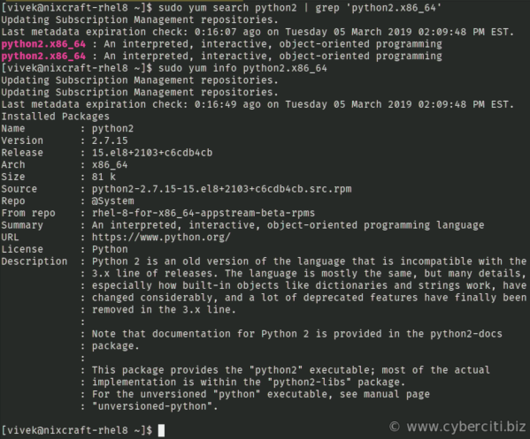

**RHEL 8 install Python 3**

Type the following [yum command](https://www.cyberciti.biz/faq/rhel-centos-fedora-linux-yum-command-howto/) to install Python 3 on Red Hat Enterprise Linux version 8:  
sudo yum install python3  
OR  
sudo yum module install python36  
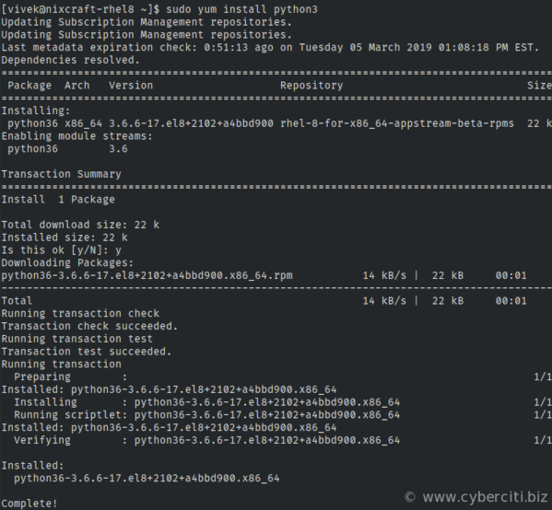  
Verify installation by typing the [type command](https://bash.cyberciti.biz/guide/Type_command)/[command command](https://bash.cyberciti.biz/guide/Command):  
$ **type -a python3**  
python3 is /usr/bin/python3  
$ **command -V python3**  
python3 is hashed (/usr/bin/python3)  
$ **python3 --version**  
Python 3.6.6

**A sample script in Python 3**

Create a file named test.py:

|  |
| --- |
| *#!/usr/bin/python3*  **import** os, time  **print**("This is a test code for Python3")  **print**("Hello %s, let us be friends!" % os.environ["USER"])  **print**("Today is %s" % time.strftime("%c")) |

Run it as follows:  
$ chmod +x test.py  
$ ./test.py  
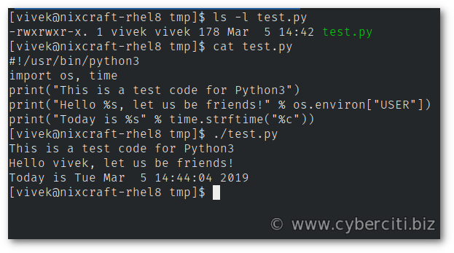

**A note for Ansible users**

Set up your hosts file as follows on your control node to use Ansible as automation tool for RHEL 8 server:

|  |
| --- |
| **[all:vars]**  ansible_user**=**vivek  ansible_port**=**22  ansible_python_interpreter**=**'/usr/bin/env python3' |

Now run it as usual:  
ansible-playbook -i hosts tasks/7-secure-rhel8-vm.yml

**RHEL 8 install Python 2**

Let us see how to install Python 2.7 on RHEL 8:  
sudo yum install python27  
OR  
sudo yum module install python27  
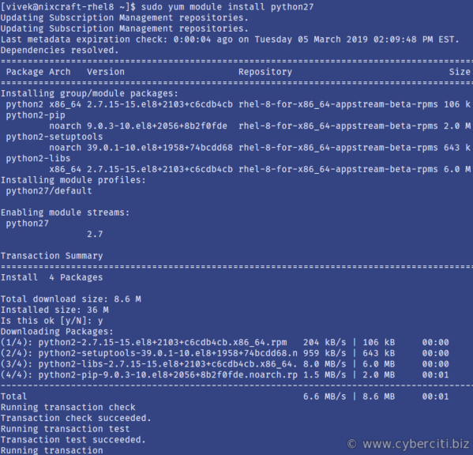  
Let us find out information about installed version of Python 2.7 in RHEL 8:  
$ type -a python2  
$ command -V python2  
$ python2 --version  
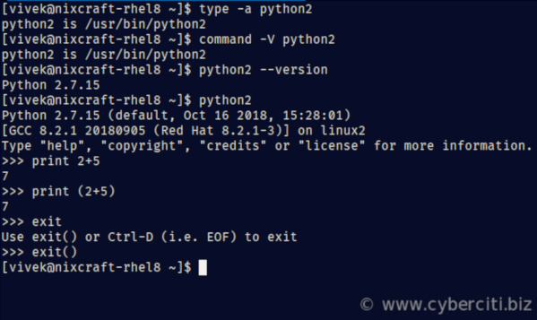

**Can I install both Python 3.6 and Python 2.7 on RHEL 8?**

Yes. It is possible to install both versions simultaneously:  
sudo yum module install python36 python27  
Sample outputs:

|  |
| --- |
| Updating Subscription Management repositories.  Updating Subscription Management repositories.  Last metadata expiration check: 0:09:22 ago on Tuesday 05 March 2019 02:09:48 PM EST.  Dependencies resolved.  **========================================================================================**  Package Arch Version Repository Size  **=**=======================================================================================  Installing group/module packages:  python36  x86_64 3.6.6-17.el8+2102+a4bbd900 rhel-8-for-x86_64-appstream-beta-rpms 22 k  python2 x86_64 2.7.15-15.el8+2103+c6cdb4cb rhel-8-for-x86_64-appstream-beta-rpms 106 k  python2-pip  noarch 9.0.3-10.el8+2056+8b2f0fde rhel-8-for-x86_64-appstream-beta-rpms 2.0 M  python2-setuptools  noarch 39.0.1-10.el8+1958+74bcdd68 rhel-8-for-x86_64-appstream-beta-rpms 643 k  python2-libs  x86_64 2.7.15-15.el8+2103+c6cdb4cb rhel-8-for-x86_64-appstream-beta-rpms 6.0 M  Installing module profiles:  python27/default    python36/default      Transaction Summary  **=**=======================================================================================  Install 5 Packages    Total download size: 8.7 M  Installed size: 36 M  Is this ok **[y/N]**: |

**How do I set default version of Python on RHEL 8?**

One can set Python 3 as default by running the simple command:  
sudo alternatives --set python /usr/bin/python3  
python --version  
Sample outputs:

Python 3.6.6

Similarly one can set Python 2 as default version for RHEL 8 based desktop or server environment from the bash shell:  
sudo alternatives --set python /usr/bin/python2  
python --version

**How do I remove python default on RHEL 8?**

The syntax is simple:  
sudo alternatives --remove python /usr/bin/python2  
OR  
sudo alternatives --remove python /usr/bin/python3